

**CAPTURED PANORAMA**

**PHOTOGRAPHY SERVICES WEBSITE**



**Documentation**

Submitted By: **MUHAMMAD JUNAID FIDA**

Registration no. **04072113048**

Course: CS-324 WAD

**Table of Contents**

1. Introduction

2. Features

3. Installation

4. Usage

5. Structure

6. Tools and Technologies

7. Database Schema

8. File Structure

9. Sign Up form

10. login Page

11. Home Page

12. About Page

13.Gallery Page

14.Book Now Page

**1. Introduction**

Captured Panorama aims to provide top-quality photography services for various events, including weddings, birthdays, and special occasions. The website serves as a platform for showcasing the photographer's portfolio and enabling users to book appointments conveniently.

**2. Features**

* Navigation menu for easy access to different sections of the website.
* Informative header section highlighting the mission statement and services offered.
* About section providing details about the photographer and the company.
* Gallery section displaying a curated collection of stunning photographs.
* Booking section allowing users to schedule appointments by filling out a form.
* Integration with PHP for handling form submissions and database interactions.

**3. Installation**

To install the website locally, follow these steps:

1. Clone the repository from GitHub.

2. Set up a local web server environment (e.g., XAMPP, WAMP).

3. Import the database schema provided in the `bookingsdb.sql` file.

4. Launch the website by accessing the `index.html` file in a web browser.

**4. Usage**

Users can navigate through different sections of the website using the navigation menu. They can explore the gallery to view various photographs and book appointments using the booking form. On clicking logo of website, user will be redirected to home page.

**5. Structure**

The website follows a structured layout with the following sections:

* Home
* About
* Gallery
* Booking

**6.Tools and Technologies**

* + HTML5
  + CSS3
  + JavaScript
  + PHP
  + SQL (MySQL)
  + Xampp Server
  + VS code

**7. Database Schema**

The database schema includes tables for users, bookings, and other relevant entities. Refer to the `bookingsdb.sql` file for details.

**8. File Structure**

* **`index.html`:** Main HTML file for the website.
* **`style.css`:** CSS file for styling the website.
* **`main.js`:** JavaScript file for interactive features.
* **`booknow.php`:** PHP file for handling booking form submissions.
* **`retrievebookings.php`:** PHP file to retrieve bookings data.
* `**images/`:** Directory containing images used in the website.
* **`bookingsdb.sql`:** SQL file containing the database schema.

**9. Signup Form**

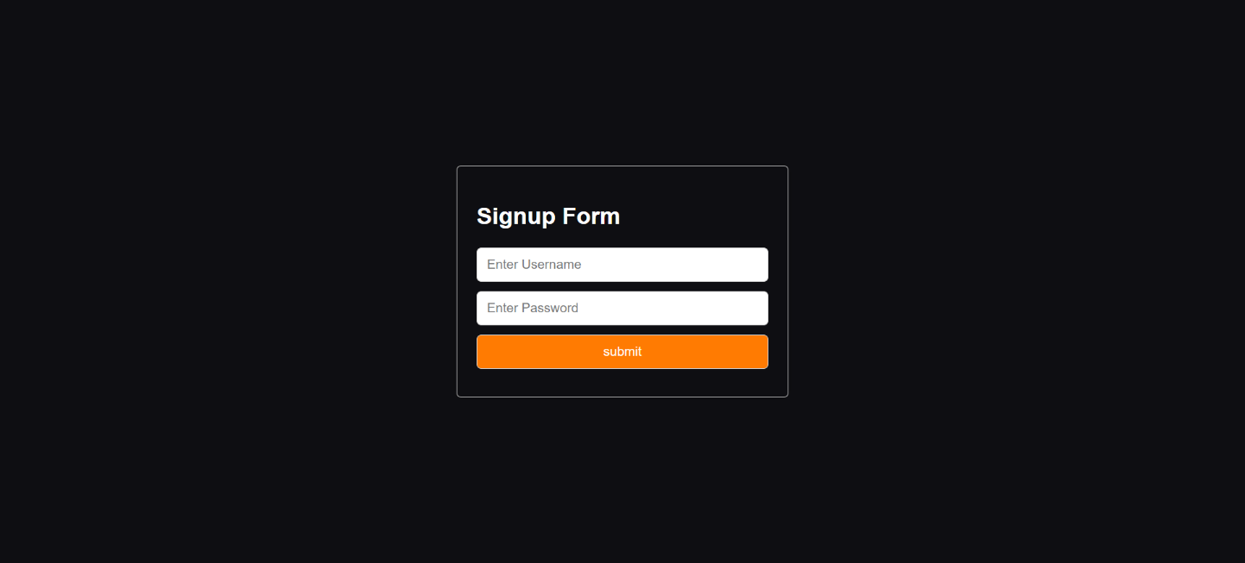

**10. Login Page**

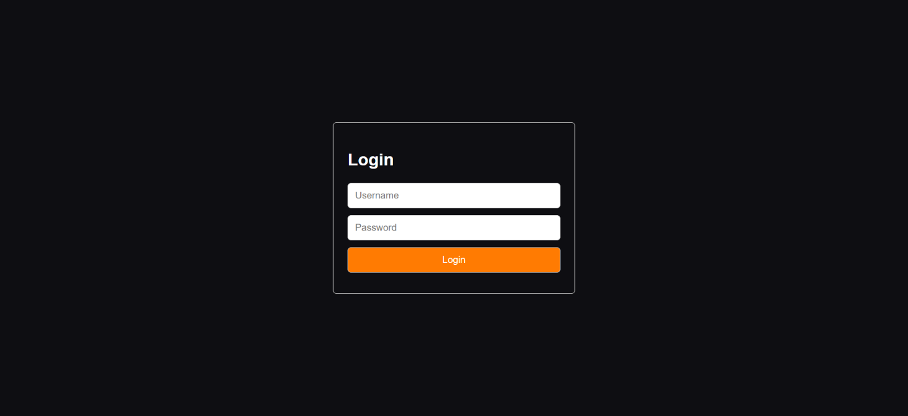

**11. Home Page**

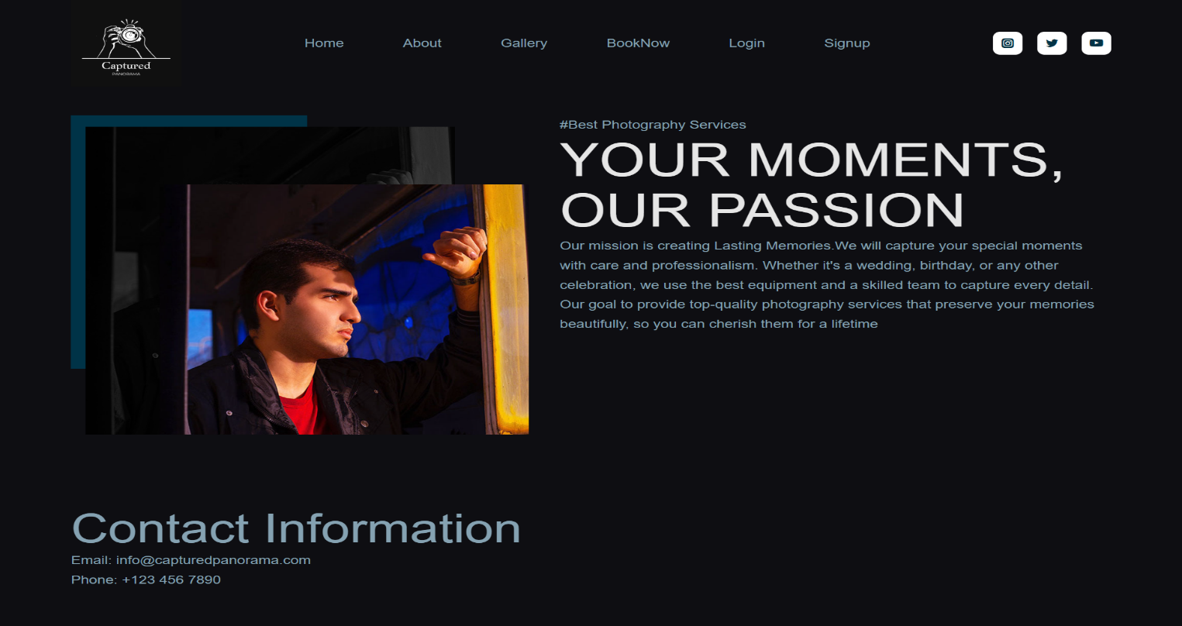

**12. About Page**

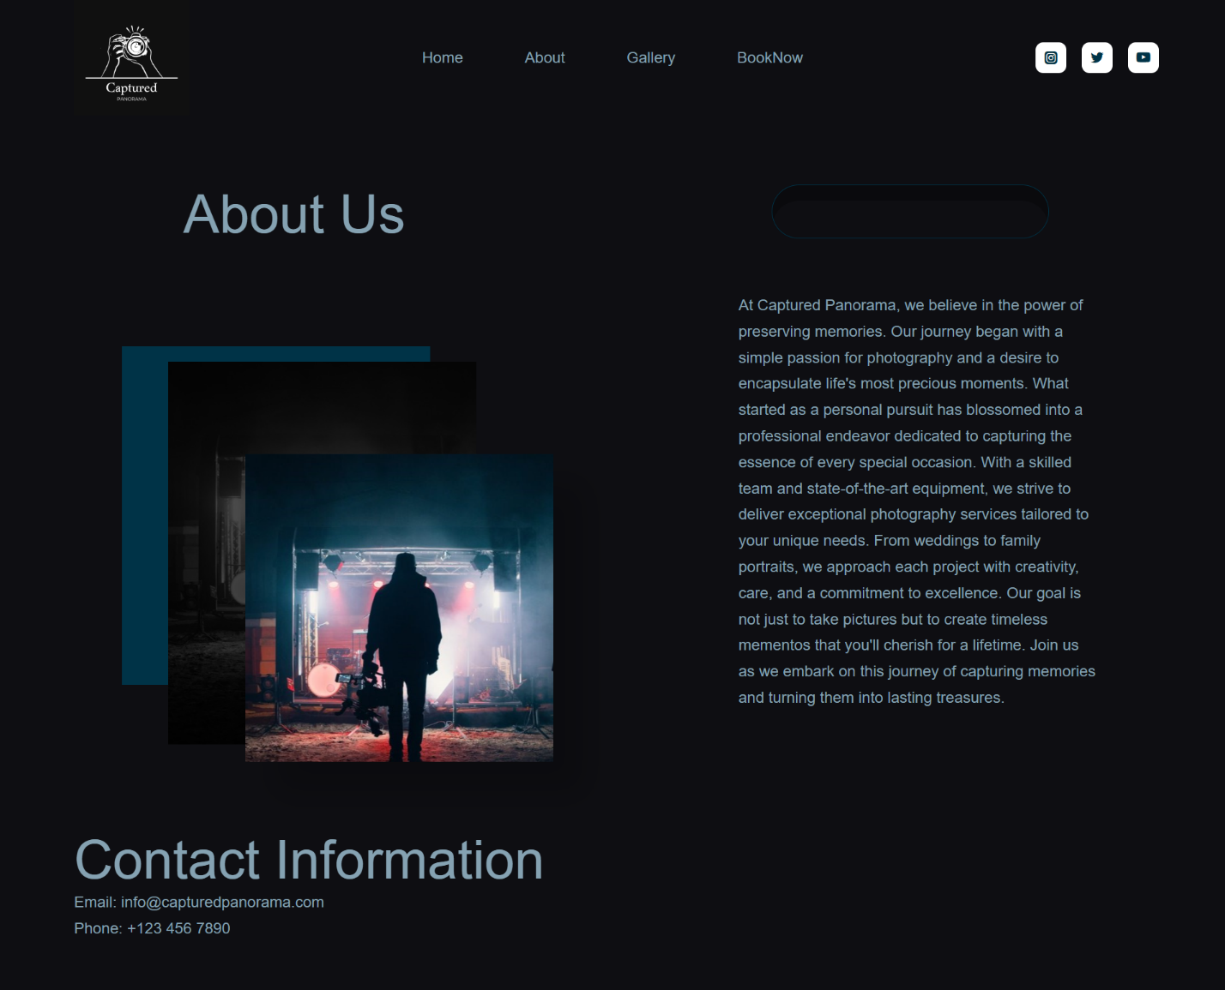

**13.Book Now Page**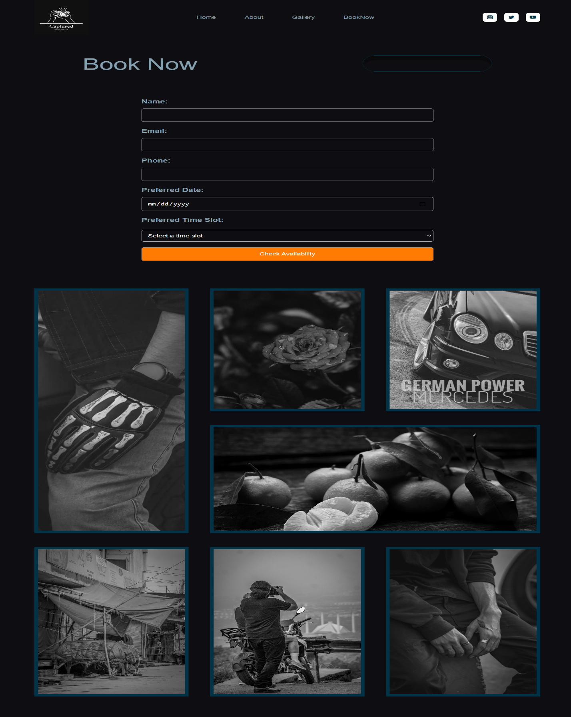

**14. Gallery Page**